Steps to Execute
- Open the project root directory, where the make file is located.
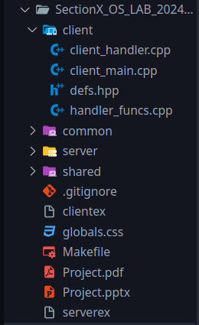

- Use command “make server” and “make client” to make the server and client file.
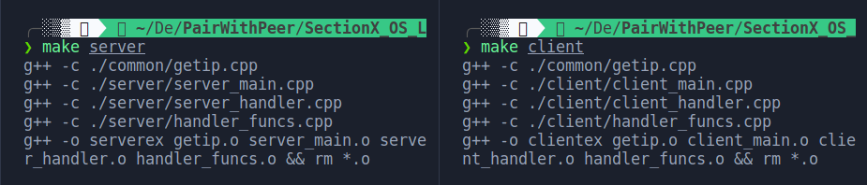

- To start the server, we execute the server binary file, and for the client, the client executable.

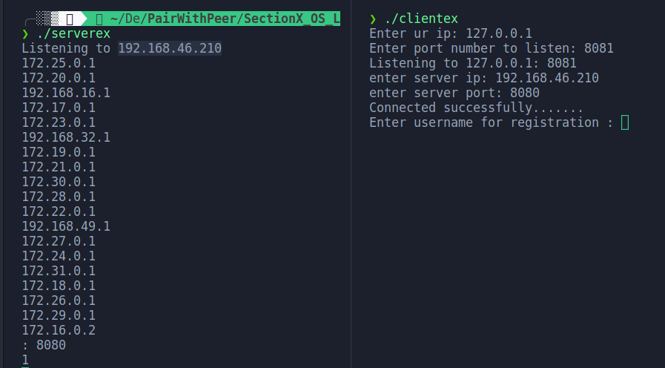

- After starting the server, we need to provide the Ip address of the server machine and the port to listen to.
- For the client, we need to provide the Ip address and port of server machine.

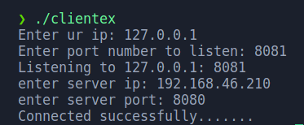

- After that we get two choices for client --- download and list files.

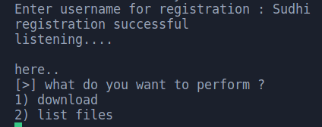

- “List” option will list files present in the shared/public directory under the root directory of all the connected clients.

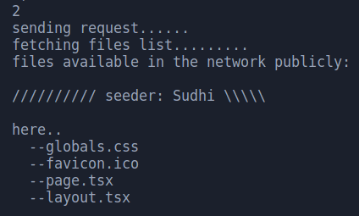

8. “Download” option will download the selected file in the client.

